Batch: A2 Roll No.: 16010322014
Experiment / assignment / tutorial No. 9
Grade: AA / AB / BB / BC / CC / CD /DD
Signature of the Staff In-charge with date

Title: Configuring Basic EIGRP for IPv6

Objectives:
Part 1: Build the Network and Verify Connectivity Part 2: Configure EIGRP for IPv6 Routing
Part 3: Verify EIGRP for IPv6 Routing
Part 4: Configure and Verify Passive Interfaces

OUTCOME:
CO 4. Implement Enhanced Interior Gateway Routing Protocol (EIGRP)
Packet Tracer software
Tools required:

Theory:
EIGRP for IPv6 has the same overall operation and features as EIGRP for IPv4. However, there are a few major differences between them:
- EIGRP for IPv6 is configured directly on the router interfaces.
- With EIGRP for IPv6, a router ID is required on each router or the routing process does not
start.
- The EIGRP for IPv6 routing process uses a shutdown feature.
Configure the network with EIGRP routing for IPv6. Assign router IDs, configure passive interfaces, verify the network is fully converged, and display routing information using CLI show commands
Task: Topology

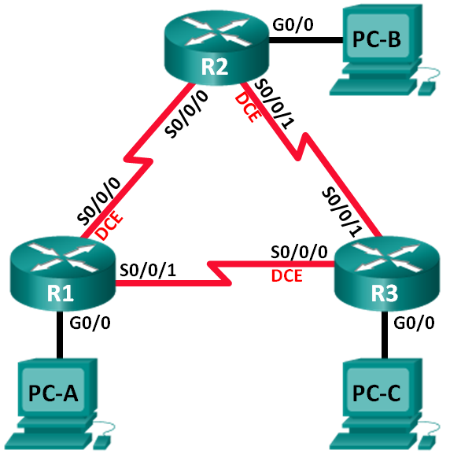

Addressing Table

Device | Interface | IP Address | Default Gateway
R1 | G0/0 | 2001:DB8:ACAD:A::1/64  FE80::1 link-local | N/A
 | S0/0/0 (DCE) | 2001:DB8:ACAD:12::1/64  FE80::1 link-local | N/A
 | S0/0/1 | 2001:DB8:ACAD:13::1/64  FE80::1 link-local | N/A
R2 | G0/0 | 2001:DB8:ACAD:B::1/64  FE80::2 link-local | N/A
 | S0/0/0 | 2001:DB8:ACAD:12::2/64  FE80::2 link-local | N/A
 | S0/0/1 (DCE) | 2001:DB8:ACAD:23::2/64  FE80::2 link-local | N/A
R3 | G0/0 | 2001:DB8:ACAD:C::1/64  FE80::3 link-local | N/A
 | S0/0/0 (DCE) | 2001:DB8:ACAD:13::3/64  FE80::3 link-local | N/A
 | S0/0/1 | 2001:DB8:ACAD:23::3/64  FE80::3 link-local | N/A
PC-A | NIC | 2001:DB8:ACAD:A::3/64 | FE80::1
PC-B | NIC | 2001:DB8:ACAD:B::3/64 | FE80::2
PC-C | NIC | 2001:DB8:ACAD:C::3/64 | FE80::3

Part 1: Build the Network and Verify Connectivity
In Part 1, you will set up the network topology and configure basic settings, such as the interface IP addresses, device access, and passwords.

Step 1: Cable the network as shown in the topology.

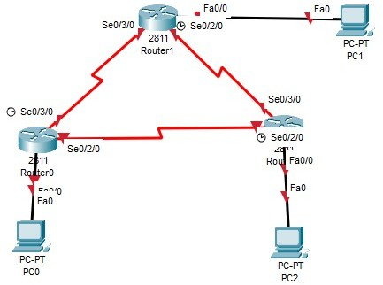

Step 2: Configure PC hosts.
Step 3: Initialize and reload the routers as necessary. Step 4: Configure basic settings for each router.
- Disable DNS lookup.
- Configure IP addresses for the routers as listed in Addressing Table.
Note: Configure the FE80::x link-local address and the unicast address for each router interface.
- Configure the device name as shown in the topology.
- Assign cisco as the console and vty passwords.
- Assign class as the privileged EXEC password.
- Configure logging synchronous to prevent console and vty messages from interrupting command entry.
- Configure a message of the day.
- Copy the running configuration to the startup configuration.

Step 5: Verify connectivity.
The routers should be able to ping one another, and each PC should be able to ping its default gateway. The PCs will not be able to ping other PCs until EIGRP routing is configured. Verify

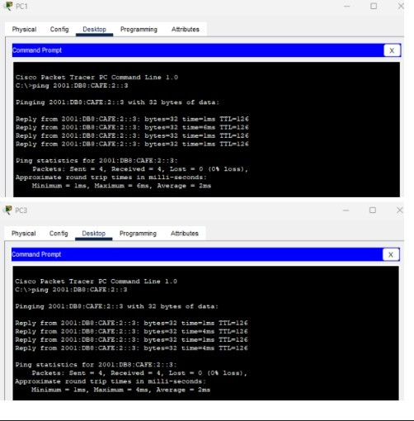
and troubleshoot if necessary.

Part 2: Configure EIGRP for IPv6 Routing Step 1: Enable IPv6 routing on the routers.
R1(config)# ipv6 unicast-routing

Step 2: Assign a router ID to each router.
- To begin the EIGRP for IPv6 routing configuration process, issue the ipv6 router eigrp 1
command, where 1 is the AS number.
R1(config)# ipv6 router eigrp 1
- EIGRP for IPv6 requires a 32-bit address for the router ID. Use the eigrp router-id
command to configure the router ID in the router configuration mode. R1(config)# ipv6 router eigrp 1
R1(config-rtr)# eigrp router-id 1.1.1.1

R2(config)# ipv6 router eigrp 1
R2(config-rtr)# eigrp router-id 2.2.2.2

R3(config)# ipv6 router eigrp 1
R3(config-rtr)# eigrp router-id 3.3.3.3
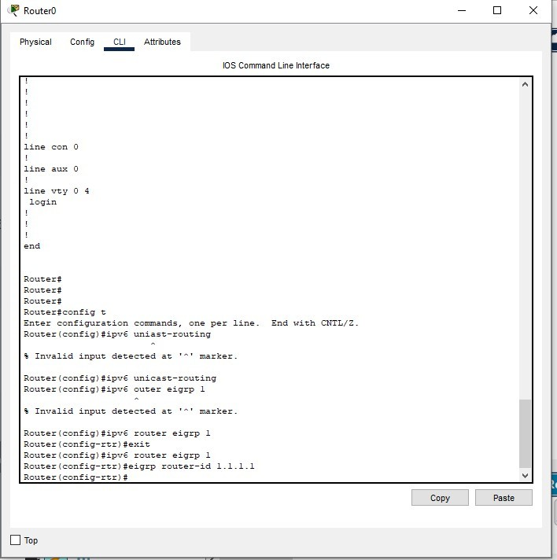

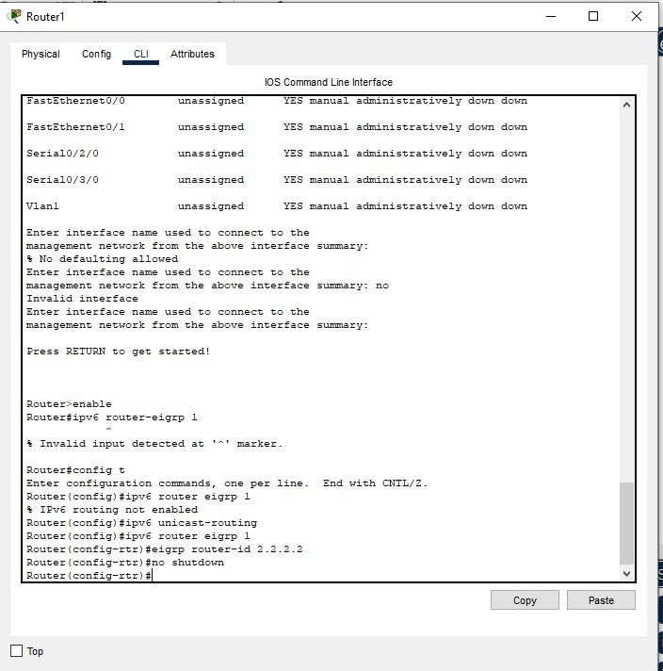

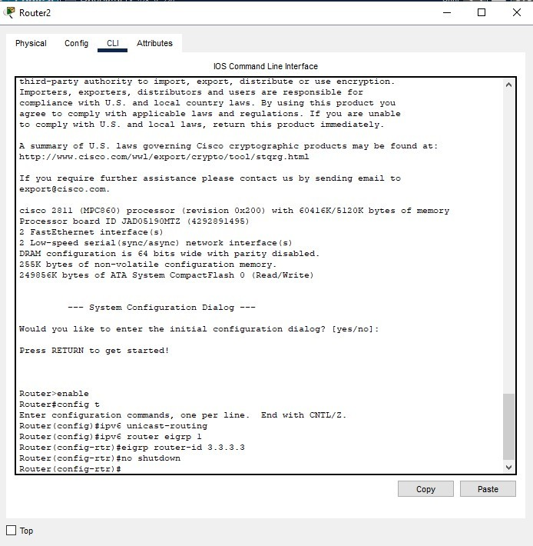

Step 3: Enable EIGRP for IPv6 routing on each router.
The IPv6 routing process is shut down by default. Issue the no shutdown command to enable EIGRP for IPv6 routing on all routers.
R1(config)# ipv6 router eigrp 1
R1(config-rtr)# no shutdown

R2(config)# ipv6 router eigrp 1
R2(config-rtr)# no shutdown

R3(config)# ipv6 router eigrp 1
R3(config-rtr)# no shutdown

Step 4: Configure EIGRP for IPv6 using AS 1 on the Serial and Gigabit Ethernet interfaces on the routers.
- Issue the ipv6 eigrp 1 command on the interfaces that participate in the EIGRP routing process. The AS number is 1 as assigned in Step 2. The configuration for R1 is displayed below as an example.
R1(config)# interface g0/0 R1(config-if)# ipv6 eigrp 1 R1(config-if)# interface s0/0/0 R1(config-if)# ipv6 eigrp 1 R1(config-if)# interface s0/0/1 R1(config-if)# ipv6 eigrp 1
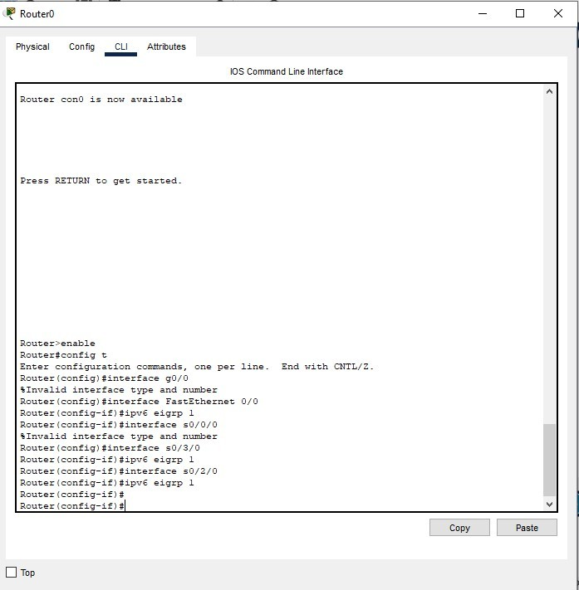

- Assign EIGRP participating interfaces on R2 and R3. You will see neighbor adjacency messages as interfaces are added to the EIGRP routing process. The messages on R1 are displayed below as an example.
R1(config-if)#
*Apr 12 00:25:49.183: %DUAL-5-NBRCHANGE: EIGRP-IPv6 1: Neighbor FE80::2
(Serial0/0/0) is up: new adjacency
*Apr 12 00:26:15.583: %DUAL-5-NBRCHANGE: EIGRP-IPv6 1: Neighbor FE80::3
(Serial0/0/1) is up: new adjacency
What address is used to indicate the neighbor in the adjacency messages?
The link-local address (FE80::x) of the neighbor’s interface, which was assigned in Part 1 Step 4.

Step 5: Verify end-to-end connectivity.
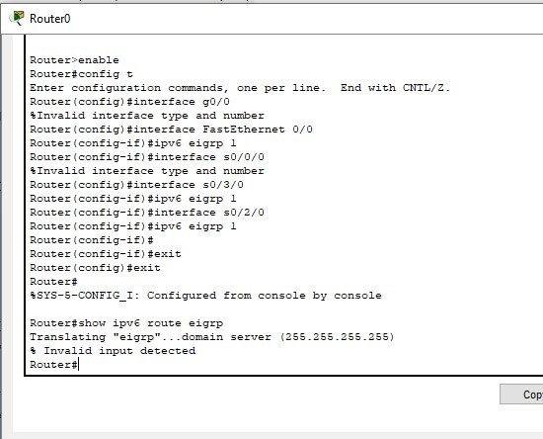
Part 3: Verify EIGRP for IPv6 Routing Step 1: Examine the neighbor adjacencies.
On R1, issue the show ipv6 eigrp neighbors command to verify that the adjacency has been established with its neighboring routers. The link-local addresses of the neighboring routers are displayed in the adjacency table.

R1# show ipv6 eigrp neighbors
EIGRP-IPv6 Neighbors for AS(1)
H Address Interface Hold Uptime SRTT RTO Q Seq

(sec) (ms) Cnt Num
1 Link-local address: Se0/0/1 13 00:02:42 1 100 0 7 FE80::3
0 Link-local address: Se0/0/0 13 00:03:09 12 100 0 9 FE80::2

Step 2: Examine the IPv6 EIGRP routing table.
Use the show ipv6 route eigrp command to display IPv6 specific EIGRP routes on all the routers.

R1# show ipv6 route eigrp
IPv6 Routing Table - default - 10 entries
Codes: C - Connected, L - Local, S - Static, U - Per-user Static route B - BGP, R - RIP, I1 - ISIS L1, I2 - ISIS L2
IA - ISIS interarea, IS - ISIS summary, D - EIGRP, EX - EIGRP external ND - ND Default, NDp - ND Prefix, DCE - Destination, NDr - Redirect O - OSPF Intra, OI - OSPF Inter, OE1 - OSPF ext 1, OE2 - OSPF ext 2 ON1 - OSPF NSSA ext 1, ON2 - OSPF NSSA ext 2
D 2001:DB8:ACAD:B::/64 [90/2172416]
via FE80::2, Serial0/0/0
D 2001:DB8:ACAD:C::/64 [90/2172416]
via FE80::3, Serial0/0/1
D 2001:DB8:ACAD:23::/64 [90/2681856]
via FE80::2, Serial0/0/0 via FE80::3, Serial0/0/1

Step 3: Examine the EIGRP topology.
R1# show ipv6 eigrp topology
EIGRP-IPv6 Topology Table for AS(1)/ID(1.1.1.1)
Codes: P - Passive, A - Active, U - Update, Q - Query, R - Reply, r - reply Status, s - sia Status

P 2001:DB8:ACAD:A::/64, 1 successors, FD is 28160 via Connected, GigabitEthernet0/0
P 2001:DB8:ACAD:C::/64, 1 successors, FD is 2172416 via FE80::3 (2172416/28160), Serial0/0/1
P 2001:DB8:ACAD:12::/64, 1 successors, FD is 2169856
via Connected, Serial0/0/0
P 2001:DB8:ACAD:B::/64, 1 successors, FD is 2172416 via FE80::2 (2172416/28160), Serial0/0/0
P 2001:DB8:ACAD:23::/64, 2 successors, FD is 2681856

via FE80::2 (2681856/2169856), Serial0/0/0 via FE80::3 (2681856/2169856), Serial0/0/1
P 2001:DB8:ACAD:13::/64, 1 successors, FD is 2169856
via Connected, Serial0/0/1
Compare the highlighted entries to the routing table. What can you conclude from the comparison?

The topology table lists all the available routes to a destination. The routing table lists the best path to a destination

Step 4: Verify the parameters and current state of the active IPv6 routing protocol processes.
Issue the show ipv6 protocols command to verify the configured parameter. From the output, EIGRP is the configured IPv6 routing protocol with 1.1.1.1 as the router ID for R1. This routing protocol is associated with autonomous system 1 with three active interfaces: G0/0, S0/0/0, and S0/0/1.

R1# show ipv6 protocols
IPv6 Routing Protocol is "connected" IPv6 Routing Protocol is "ND"
IPv6 Routing Protocol is "eigrp 1" EIGRP-IPv6 Protocol for AS(1)
Metric weight K1=1, K2=0, K3=1, K4=0, K5=0 NSF-aware route hold timer is 240
Router-ID: 1.1.1.1
Topology : 0 (base) Active Timer: 3 min
Distance: internal 90 external 170
Maximum path: 16
Maximum hopcount 100 Maximum metric variance 1

Interfaces: GigabitEthernet0/0 Serial0/0/0 Serial0/0/1 Redistribution: None

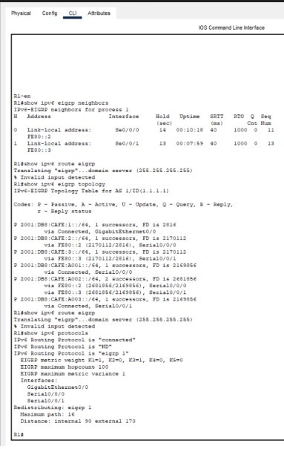

Part 4: Configure and Verify Passive Interfaces
A passive interface does not allow outgoing and incoming routing updates over the configured interface. The passive-interface interface command causes the router to stop sending and receiving Hello packets over an interface.

Step 1: Configure interface G0/0 as passive on R1 and R2.
R1(config)# ipv6 router eigrp 1
R1(config-rtr)# passive-interface g0/0

R2(config)# ipv6 router eigrp 1
R2(config-rtr)# passive-interface g0/0

Step 2: Verify the passive interface configuration.
Issue the show ipv6 protocols command on R1 and verify that G0/0 has been configured as passive.

R1# show ipv6 protocols
IPv6 Routing Protocol is "connected" IPv6 Routing Protocol is "ND"
IPv6 Routing Protocol is "eigrp 1" EIGRP-IPv6 Protocol for AS(1)
Metric weight K1=1, K2=0, K3=1, K4=0, K5=0 NSF-aware route hold timer is 240
Router-ID: 1.1.1.1
Topology : 0 (base) Active Timer: 3 min
Distance: internal 90 external 170
Maximum path: 16
Maximum hopcount 100 Maximum metric variance 1

Interfaces: Serial0/0/0 Serial0/0/1
GigabitEthernet0/0 (passive) Redistribution:
None

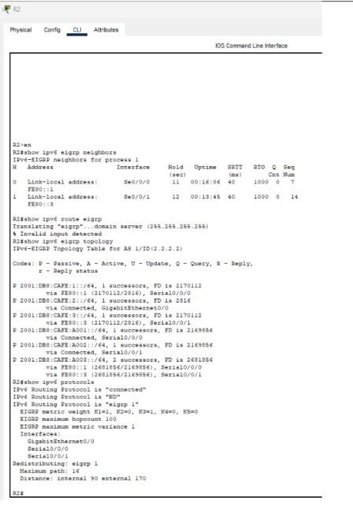

Step 3: Configure the G0/0 passive interface on R3.
If a few interfaces are configured as passive, use the passive-interface default command to configure all the interfaces on the router as passive. Use the no passive-interface interface command to allow EIGRP Hello messages in and out of the router interface.
- Configure all interfaces as passive on R3. R3(config)# ipv6 router eigrp 1
R3(config-rtr)# passive-interface default
R3(config-rtr)#
*Apr 13 00:07:03.267: %DUAL-5-NBRCHANGE: EIGRP-IPv6 1: Neighbor FE80::1
(Serial0/0/0) is down: interface passive

*Apr 13 00:07:03.267: %DUAL-5-NBRCHANGE: EIGRP-IPv6 1: Neighbor FE80::2
(Serial0/0/1) is down: interface passive
- After you have issued the passive-interface default command, R3 no longer participates in the routing process. What command can you use to verify it?

show ipv6 route eigrp or show ipv6 route
- What command can you use to display the passive interfaces on R3?

- Configure the serial interfaces to participate in the routing process. R3(config)# ipv6 router eigrp 1
R3(config-rtr)# no passive-interface s0/0/0
R3(config-rtr)# no passive-interface s0/0/1
R3(config-rtr)#
*Apr 13 00:21:23.807: %DUAL-5-NBRCHANGE: EIGRP-IPv6 1: Neighbor FE80::1
(Serial0/0/0) is up: new adjacency
*Apr 13 00:21:25.567: %DUAL-5-NBRCHANGE: EIGRP-IPv6 1: Neighbor FE80::2
(Serial0/0/1) is up: new adjacency
- The neighbor relationships have been established again with R1 and R2. Verify that only G0/0 has been configured as passive. What command do you use to verify the passive interface?

show ipv6 protocols

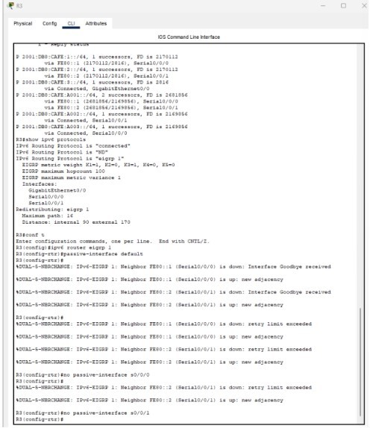

Reflection
- Where would you configure passive interfaces? Why?

Passive interfaces are usually configured on router interfaces that are not connected to other routers. Passive interfaces limit the amount of unnecessary protocol traffic in the network because no router devices are receiving the messages on the other side of the link.
- What are some advantages with using EIGRP as the routing protocol in your network?

EIGRP routing protocol can be used with almost any size network using IPv4 or IPv6. It also uses less CPU than other dynamic routing protocols, such as OSPF. It requires little bandwidth for routing updates.

Router Interface Summary Table

Router Interface Summary
Router Model | Ethernet Interface #1 | Ethernet Interface #2 | Serial Interface #1 | Serial Interface  #2
1800 | Fast Ethernet 0/0 (F0/0) | Fast Ethernet 0/1 (F0/1) | Serial 0/0/0 (S0/0/0) | Serial 0/0/1 (S0/0/1)
1900 | Gigabit Ethernet 0/0 (G0/0) | Gigabit Ethernet 0/1 (G0/1) | Serial 0/0/0 (S0/0/0) | Serial 0/0/1 (S0/0/1)
2801 | Fast Ethernet 0/0 (F0/0) | Fast Ethernet 0/1 (F0/1) | Serial 0/1/0 (S0/1/0) | Serial 0/1/1 (S0/1/1)
2811 | Fast Ethernet 0/0 (F0/0) | Fast Ethernet 0/1 (F0/1) | Serial 0/0/0 (S0/0/0) | Serial 0/0/1 (S0/0/1)
2900 | Gigabit Ethernet 0/0 (G0/0) | Gigabit Ethernet 0/1 (G0/1) | Serial 0/0/0 (S0/0/0) | Serial 0/0/1 (S0/0/1)

Signature of faculty in-charge

